

Cegedim SA ENXTPA:CGM
FQ2 2019 Earnings Call Transcripts
Thursday, July 25, 2019 4:15 PM GMT
S&P Global Market Intelligence Estimates
 | -FQ1 2019- | -FQ2 2019- |  |  | -FY 2019- | -FY 2020-
 | CONSENSUS | CONSENSUS | ACTUAL | SURPRISE | CONSENSUS | CONSENSUS
EPS Normalized | - | - | - | - | 1.44 | 1.62
Revenue (mm) | 115.40 | 120.30 | 126.60 | 5.24 | 490.61 | 509.83
Currency: EUR
Consensus as of Jul-18-2019 9:45 AM GMT

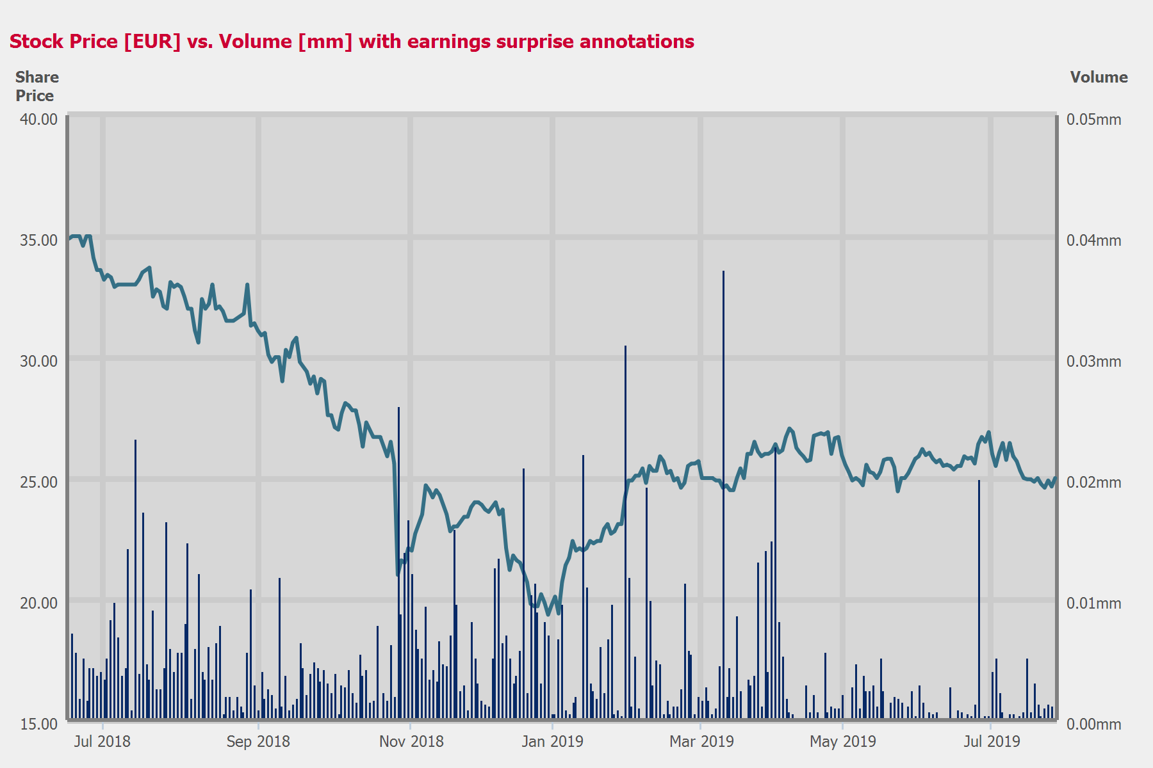
 |  |  |  | - EPS NORMALIZED -
 | CONSENSUS |  | ACTUAL |  | SURPRISE
FQ2 2018 | - |  | - |  | -
FQ3 2018 | - |  | - |  | -
FQ4 2018 | - |  | - |  | -
FQ1 2019 | - |  | - |  | -

Table of Contents

Call Participants | ........................................................................................................................................................ | 3
Presentation | ........................................................................................................................................................ | 4
Question and Answer | ........................................................................................................................................................ | 6

Call Participants
EXECUTIVES
Jan Eryk Umiastowski
Chief Investment Officer, Head of Investor Relations & Director of Financial Communications

Presentation
Operator
Ladies and gentlemen, good day and welcome to the Cegedim Web Conference. Today's conference is being recorded and will be available on the company website. This presentation will be followed by a Q&A session. At this time, I would like to turn the conference over to Mr. Jan Eryk Umiastowski, Cegedim Chief Investment Officer and Head of Investor Relations. Sir, please go ahead.
Jan Eryk Umiastowski
Chief Investment Officer, Head of Investor Relations & Director of Financial Communications
Good morning, and good evening, everyone. Thank you for joining us to discuss Cegedim's second quarter 2019 revenue.
Before we begin, I would like to remind you that this presentation and conference call may constitute forward-looking statements. These forward-looking statements may include comments about our guidance, our expectation and prospect, and are based on our view as of today, July 25, 2019.
Any such statement and projection reflect values, estimates and assumption by management concerning anticipated results. Additional information concerning important factors that may cause our results to differ materially from expectation and underlying assumption, please refer to our registration document, specifically the Risk Factors section. We undertake no obligation to correct or update this forward-looking statement whether as a result of new information, future events or otherwise.
Having this in mind, I will turn on Page 3 of this presentation. So Cegedim revenue growth pick up speed in the second quarter of 2019. Like-for-like revenue grew by 8.2% over the quarter. Growth at the Health insurance, HR and e-services division remained robust and grow as the Healthcare professionals division pick up speed in the second quarter. As you may see, we moved revenue from EUR 115.7 million to EUR 126.6 million. Organic growth 8.2%, then we get the positive impact from acquisition of BSV and XimantiX 1.1% and roughly no effect from currency. And this translate back to reported increase on revenue by 9.4% in the second quarter.
This 8.2% increase on organic compared to an increase of 4.6% in the first quarter. So 4.6% in the first quarter, 8.2% in the second. This lead to an increase for the first half of 2019 of 6.4% organically. Then we get the positive impact of BSV and XimantiX for 1.3%, roughly no impact from currency. This lead to an increase of revenue of 8% in the first half of 2019 on a reported basis, and then revenue moved from EUR 227.6 million to EUR 245.8 million of revenue in the first half of '19. This significant part is done in Europe with 86% of revenue generated in Europe, 10% in U.K. and 2.3% in the U.S.
Part of this increase of revenue are moving on Slide 5. It's related to an increase on our BPO activity. In the first quarter of this year, BPO activity increased by 25%. In the second quarter, this increased by 16%. So this lead to an increase of 20% for the first half and this now represent EUR 21.5 million of revenue. So a little less than 10% is on BPO. And may I remind that part of the BPO activity are lower margin than the remaining part of the business.
So as the BPO activity increased by 20% in the first half of 2019, this lead on, as you may see on Slide 6, that the headcount, total headcount of the Cegedim Group increased by 4.8% to 4,722 (sic) [ 4,782 ] employees at end of June. Part of this increase is related to the increase of our BPO activity and specifically, to the fact that we have gained on BPO the contract with BCAC.
Moving on Slide 7. So you see that for the second quarter of 2019, the breakdown of growth rate by business group, by division. So at the group level, this is EUR 126.6 million of revenue, an increase of 9.4% on a reported basis and 8.2% on a like-for-like. As you may see, the second -- the first division Health insurance, HR and e-services increased by 8.7% on a reported basis and by 7.5% on a like-for-like basis. This is an acceleration compared to the first quarter, where revenue increased by 6.4%, and this represents 2/3 of the total revenue of the group. 1/3 of revenue of the group is coming from Healthcare professionals. And you see that the -- we have seen a small increase in the first quarter by 1.7%, but in the second quarter, revenue increased by 10.2% on a like-for-like basis and 11.4% on a reported basis. Of course, if you look 1 year forward, you see that in the second quarter 2018 we've been down by 6.8%. So we have to -- we compensate this decrease, and we also have some increase of revenue. There is some base effect related to that.
So this translate on Slide 8 on -- for the half year. So still the breakdown between those 2 divisions is 2/3 for Health insurance, HR and e-services and 1/3 for Healthcare professionals. So Health insurance, HR and e-services increased by 8.7% on a reported basis. This is an increase of 6.9% for the first 6 months of the year. And Healthcare professionals increased by 7.1% on a reported basis and 5.9% on a like-for-like. So we see a significant increase, well ahead of the 5% on both divisions, 6.9% the first one and 5.9% the second one. This lead to an increase of 6.4% total for the group.
Now regarding more precisely by division on Slide 9. What contributed to the growth? So first biggest contributors is the first division, due to the fact that it represent 2/3 of the revenue. But also, we see significant acceleration of growth rate on Healthcare professionals.
On the first division, Health insurance, HR and e-services, the main driver for the increase of revenue are the BPO activity related to the insurance activities, the third-party payment flow in Europe -- in France, sorry, the Cegedim Healthcare data, so all the data and analysis that we provide to the healthcare market that is growing as we are also opening some new countries, the electronic invoicing with Cegedim e-business and the payroll activity in France with Cegedim SRH.
Now moving to the second division, Healthcare professionals. The biggest contributors are softwares for doctors in France, but also for nurses, chiropractors, et cetera. We also have seen a positive boost on revenue coming from U.K. doctors and Romanian doctors and also from Romanian pharmacists.
So as you may look, most of the activity contribute to this growth quite significantly and which leads to the numbers that we have seen, a 6.4% increase on a like-for-like basis for the first half of 2019.
Moving on Slide 10. So a few words about Brexit. So U.K. revenue represent 10% of the total revenue of the group last year and 9.9% of EBITDA. Most of our activity in U.K. are in local currency, cost and revenue. So this really compensates. So we have just a translation impact. There is no major European health program at work in the U.K. and in all the contracts that we get with NHS doctors, pharmacists, et cetera, there is no close dealing about Brexit. We expect that the impact of our business will be quite small.
Regarding the guidance for the full year 2019, we have decided to keep the same guidance as stated in March, early this year. So 5% increase on a like-for-like basis on revenue and 5% increase on EBITDA, and we'll give more color about our guidance in September when we'll release the first half results with earning and the total P&L.
So now, I will ask our operator to open the line for the Q&A session. Thank you.

Question and Answer
Operator
[operator instructions]
Jan Eryk Umiastowski
Chief Investment Officer, Head of Investor Relations & Director of Financial Communications
So if there is no question, I think I've been crystal clear. So before we end this presentation, I would like to remind you that the key takeaway are revenue pick up speed in the second quarter of 2019. Revenue remained quite -- growth remained quite robust in the first division. And in the second division, we have seen a pick up speed in revenue growth. We are maintaining our guidance for the full year. Thank you for listening, and enjoy your summer. Thank you, bye.
OperatorLadies and gentlemen, this concludes the conference call. Thank you all for your participation. You may now disconnect.
Copyright © 2019 by S&P Global Market Intelligence, a division of S&P Global Inc. All rights reserved.
These materials have been prepared solely for information purposes based upon information generally available to the public and from sources believed to be reliable. No content (including index data, ratings, credit-related analyses and data, research, model, software or other application or output therefrom) or any part thereof (Content) may be modified, reverse engineered, reproduced or distributed in any form by any means, or stored in a database or retrieval system, without the prior written permission of S&P Global Market Intelligence or its affiliates (collectively, S&P Global). The Content shall not be used for any unlawful or unauthorized purposes. S&P Global and any third-party providers, (collectively S&P Global Parties) do not guarantee the accuracy, completeness, timeliness or availability of the Content. S&P Global Parties are not responsible for any errors or omissions, regardless of the cause, for the results obtained from the use of the Content. THE CONTENT IS PROVIDED ON "AS IS" BASIS. S&P GLOBAL PARTIES DISCLAIM ANY AND ALL EXPRESS OR IMPLIED WARRANTIES, INCLUDING, BUT NOT LIMITED TO, ANY WARRANTIES OF MERCHANTABILITY OR FITNESS FOR A PARTICULAR PURPOSE OR USE, FREEDOM FROM BUGS, SOFTWARE ERRORS OR DEFECTS, THAT THE CONTENT'S FUNCTIONING WILL BE UNINTERRUPTED OR THAT THE CONTENT WILL OPERATE WITH ANY SOFTWARE OR HARDWARE CONFIGURATION. In no event shall S&P Global Parties be liable to any party for any direct, indirect, incidental, exemplary, compensatory, punitive, special or consequential damages, costs, expenses, legal fees, or losses (including, without limitation, lost income or lost profits and opportunity costs or losses caused by negligence) in connection with any use of the Content even if advised of the possibility of such damages. S&P Global Market Intelligence's opinions, quotes and credit-related and other analyses are statements of opinion as of the date they are expressed and not statements of fact or recommendations to purchase, hold, or sell any securities or to make any investment decisions, and do not address the suitability of any security. S&P Global Market Intelligence may provide index data. Direct investment in an index is not possible. Exposure to an asset class represented by an index is available through investable instruments based on that index. S&P Global Market Intelligence assumes no obligation to update the Content following publication in any form or format. The Content should not be relied on and is not a substitute for the skill, judgment and experience of the user, its management, employees, advisors and/or clients when making investment and other business decisions. S&P Global Market Intelligence does not act as a fiduciary or an investment advisor except where registered as such. S&P Global keeps certain activities of its divisions separate from each other in order to preserve the independence and objectivity of their respective activities. As a result, certain divisions of S&P Global may have information that is not available to other S&P Global divisions. S&P Global has established policies and procedures to maintain the confidentiality of certain nonpublic information received in connection with each analytical process.
S&P Global may receive compensation for its ratings and certain analyses, normally from issuers or underwriters of securities or from obligors. S&P Global reserves the right to disseminate its opinions and analyses. S&P Global's public ratings and analyses are made available on its Web sites, www.standardandpoors.com (free of charge), and www.ratingsdirect.com and www.globalcreditportal.com (subscription), and may be distributed through other means, including via S&P Global publications and third-party redistributors. Additional information about our ratings fees is available at www.standardandpoors.com/usratingsfees.
© 2019 S&P Global Market Intelligence.

